HOW TO UPLOAD ROSTERS TO YOUR TEAM PAGE ON THE WCLA.CLUB SITE

First, go to wcla.club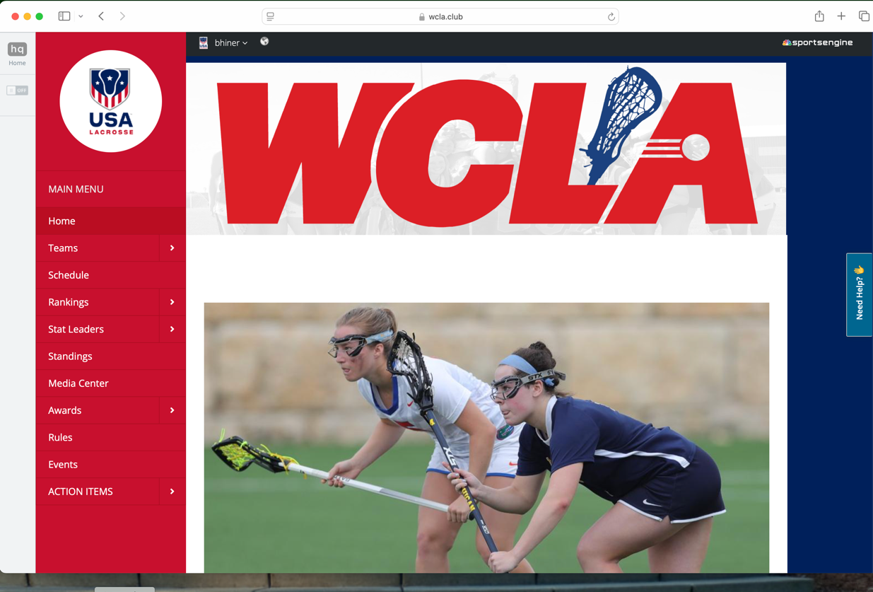

Then find and select your team
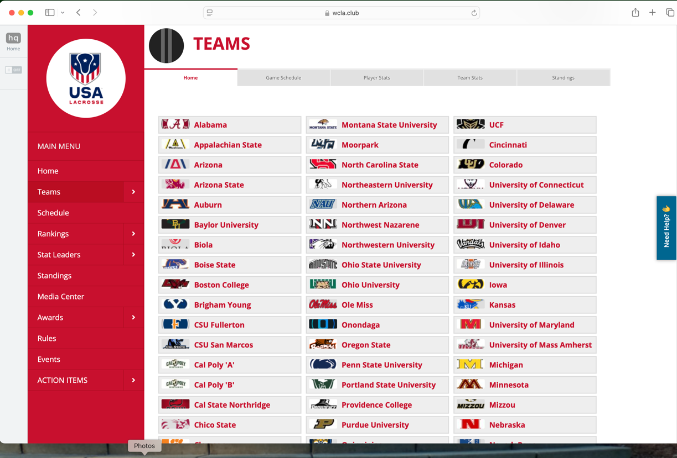

Turn “on” the edit switch


Select “Roster”


Select “Add Player”
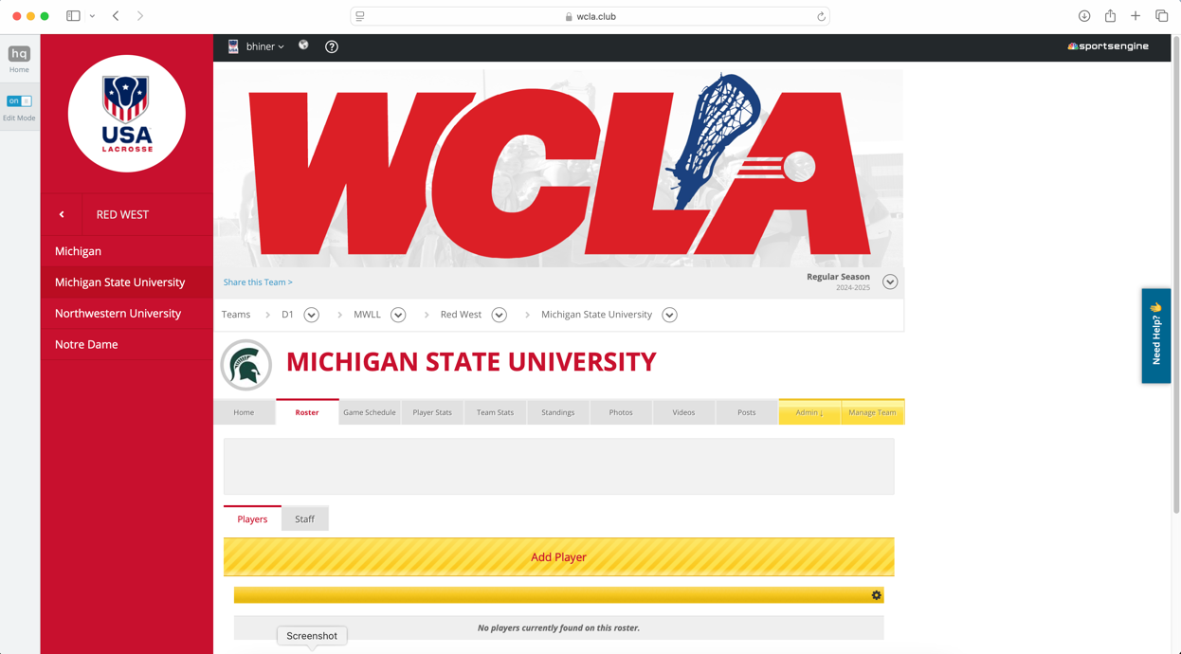

Select “Import Players From Excel”
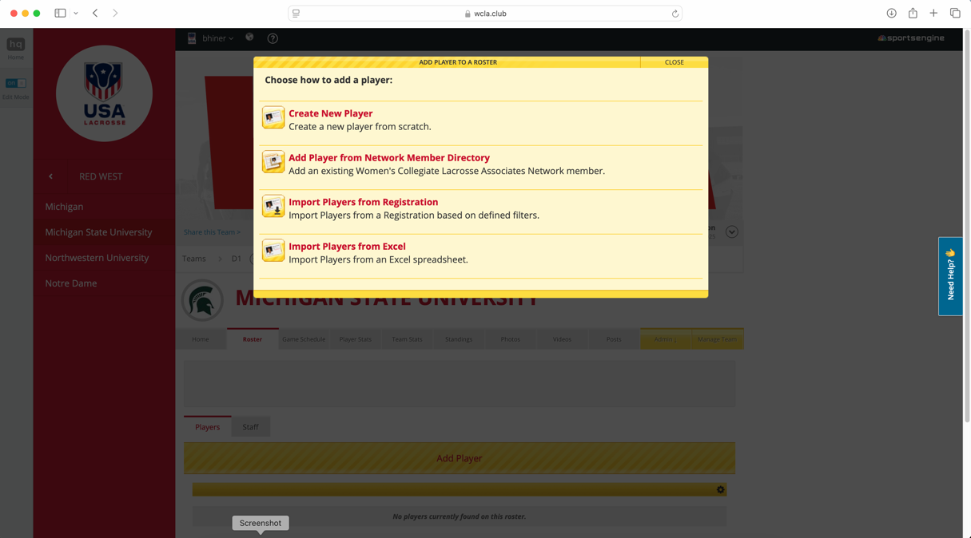

Download the roster template
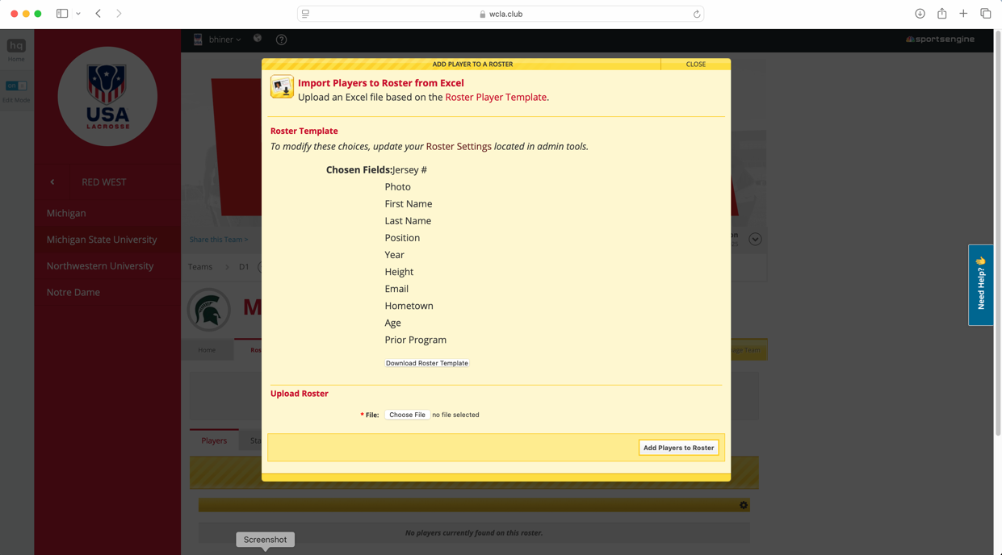

In Excel, complete the roster information for your team and save to your desktop. Then select this file to upload back into the site.
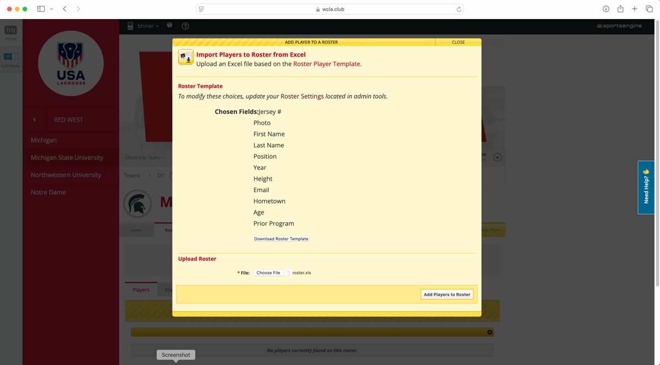
The upload should look like this in “edit mode”
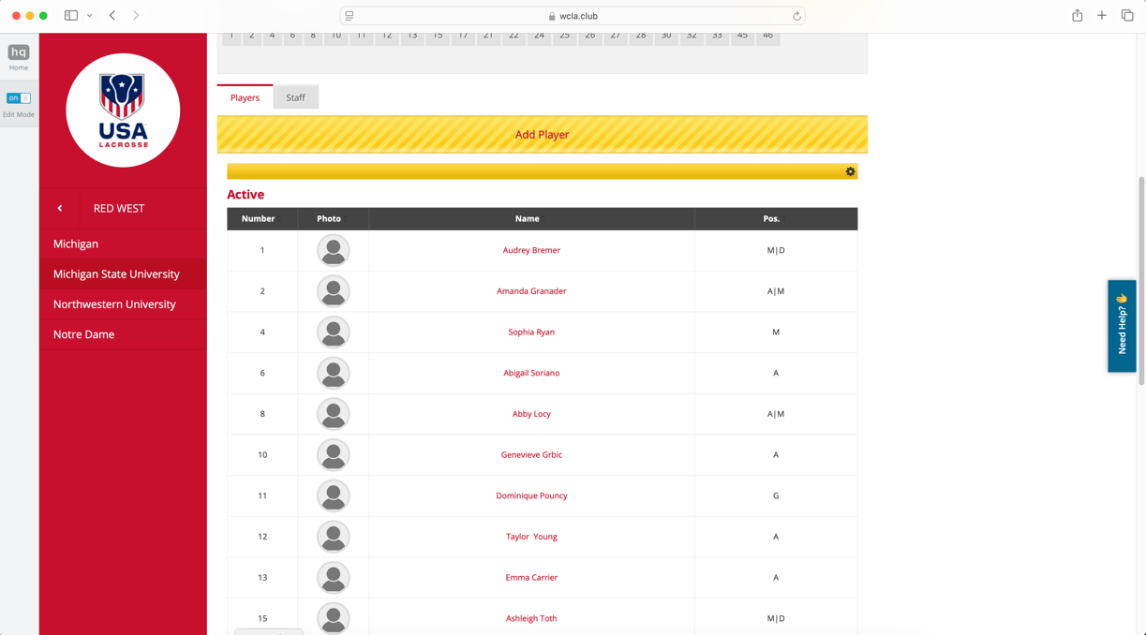

FINAL RESULTS (edit mode turned off)
